**Automating Workloads Using ARM Template.**

* Create a resource group

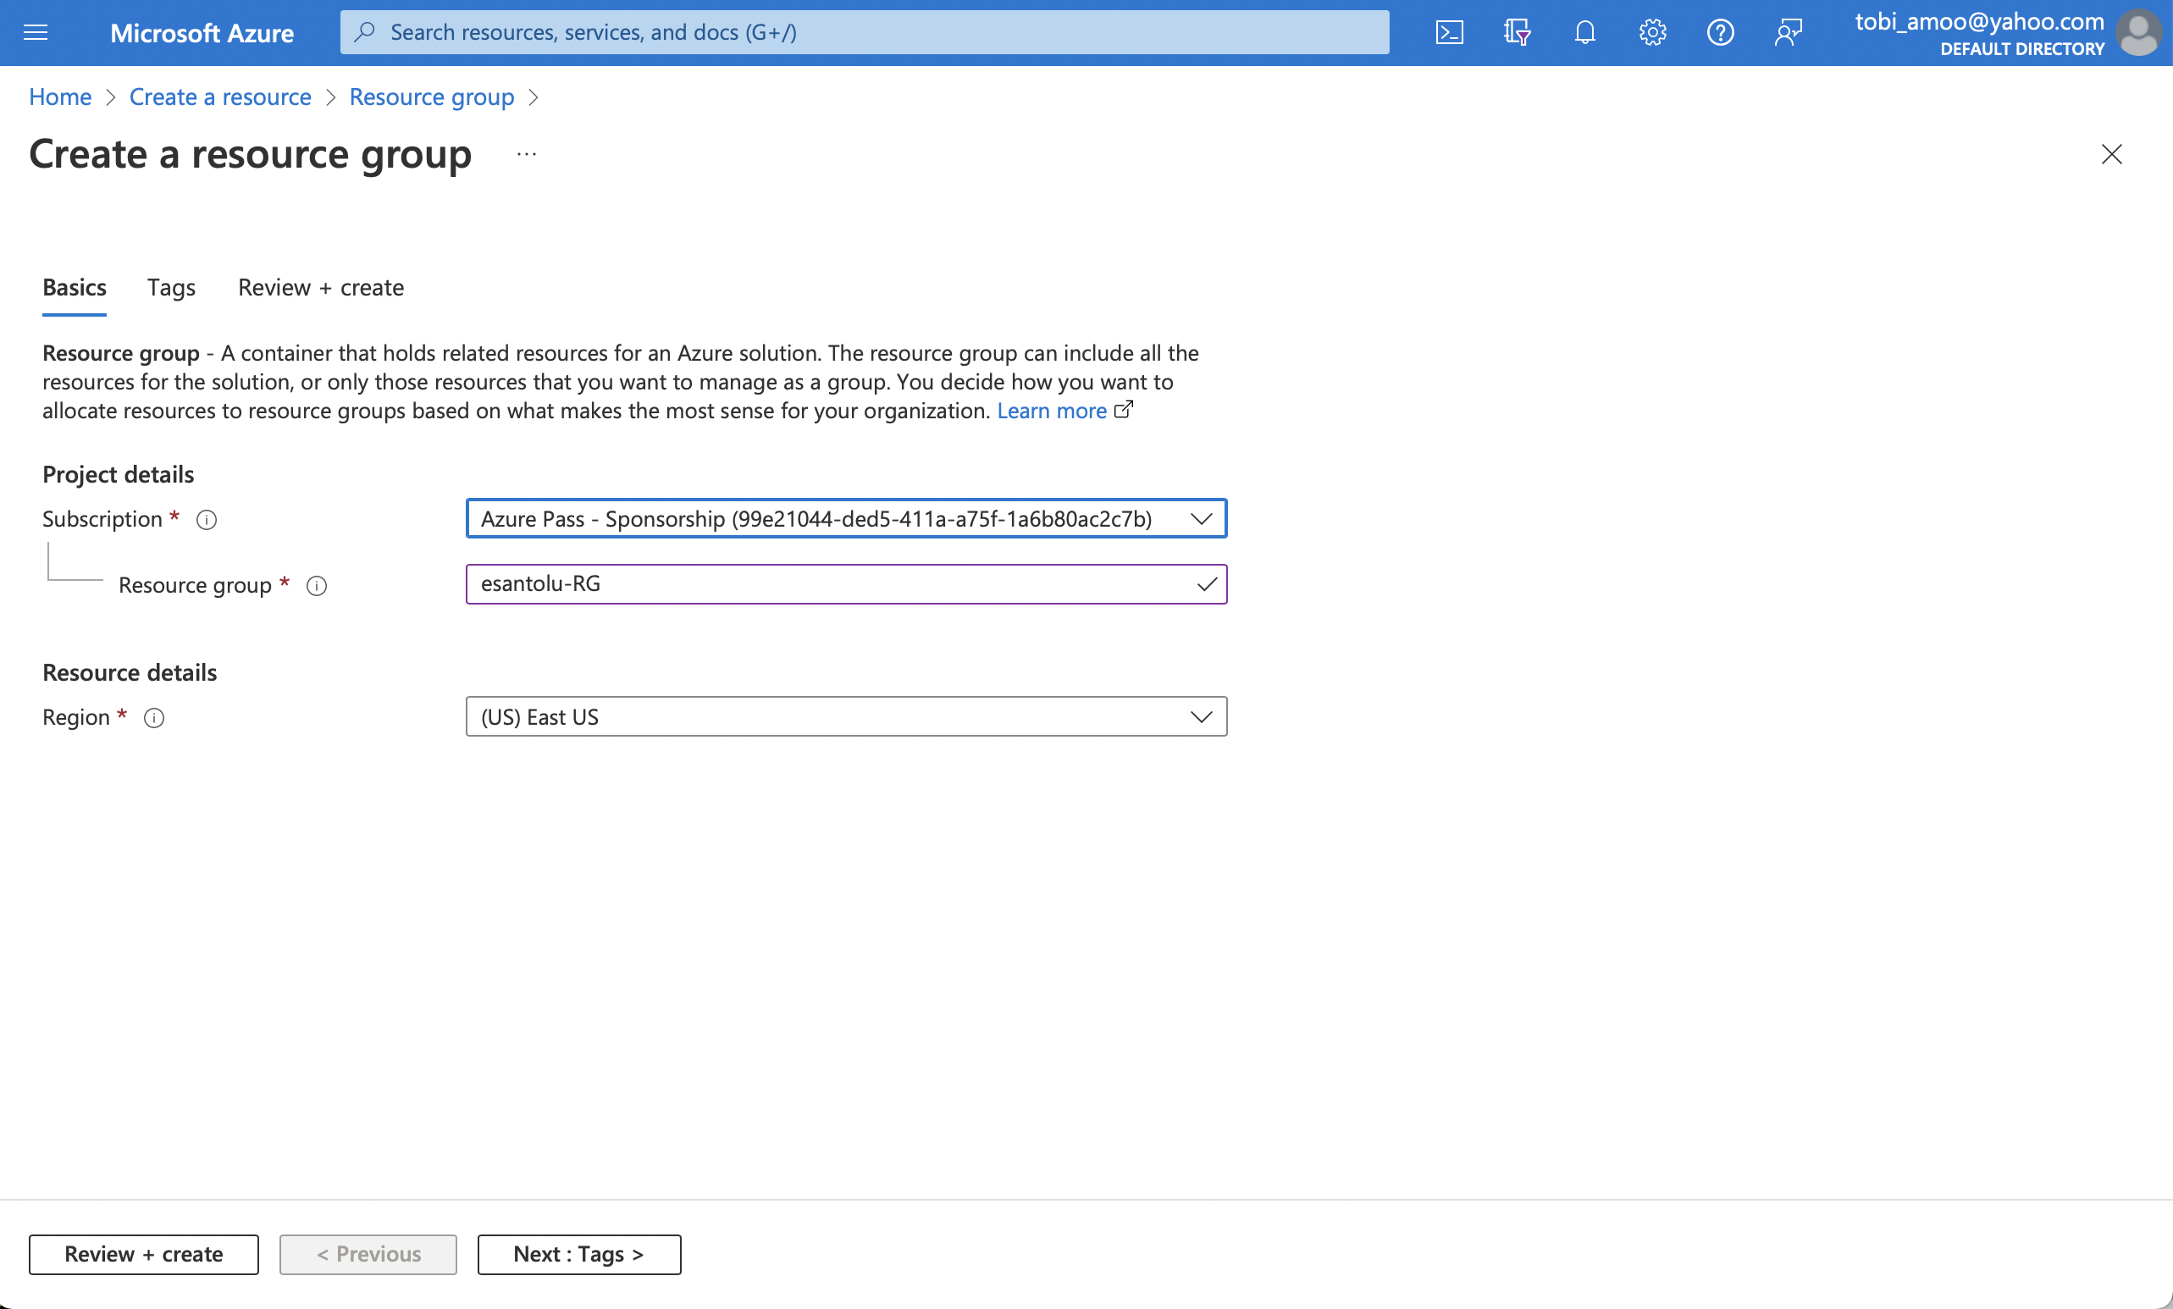

* Create a virtual machine

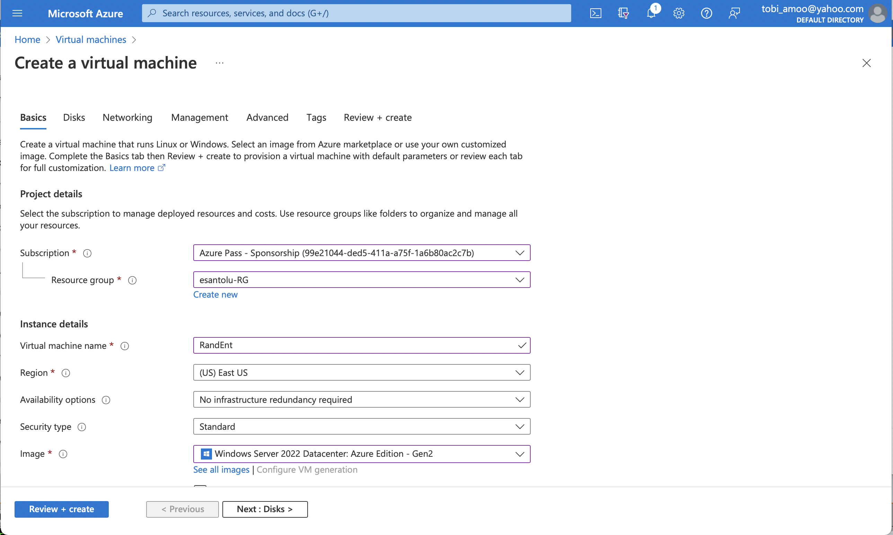

* Create a storage account

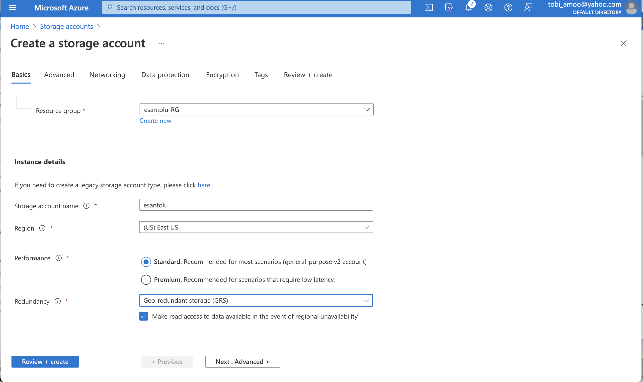

* Create container named ‘images’ inside container

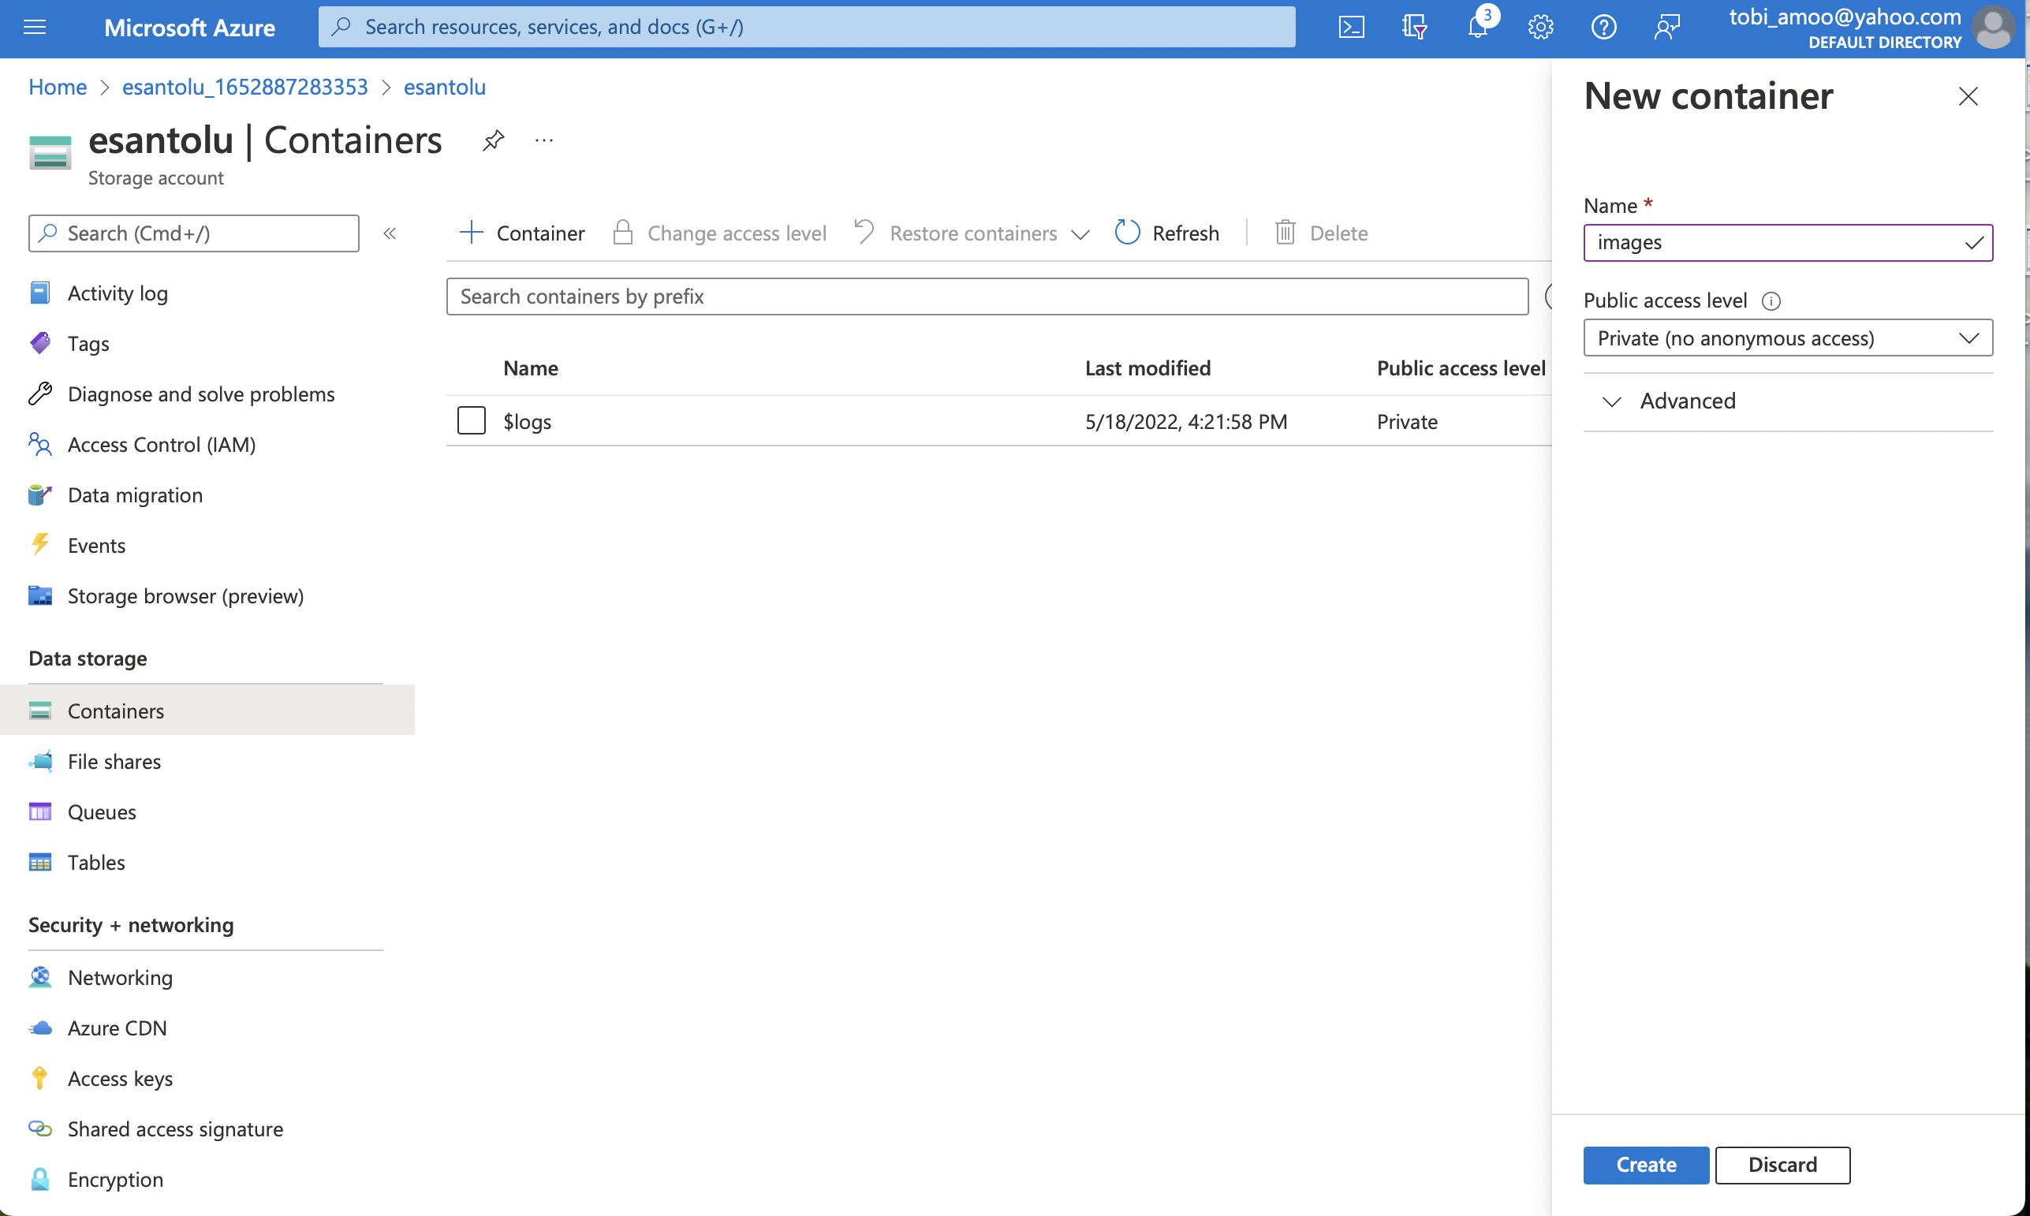

* Navigate to the Resource group and export the template